F. EXAMPLE PROJECTS WHICH BEST ILLUSTRATE PROPOSED TEAM’S QUALIFICATIONS FOR THIS CONTRACT  (Present as many projects as requested by the agency, or 10 projects, if not specified. Complete one Section F for each project.) |  |  |  |  |  | 20. EXAMPLE PROJECT KEY NUMBER  2
21. TITLE AND LOCATION (CITY AND STATE)  Caltrans District 7 – A&E On – Call Construction Plant Inspection Services (07A3126)  (Los Angeles and Ventura Counties, CA) |  |  |  | 22. YEAR COMPLETED
 |  |  |  | PROFESSIONAL SERVICES  2022 |  | CONSTRUCTION (IF APPLICABLE)  N/A
23. PROJECT OWNER’S INFORMATION
a. PROJECT OWNER  Caltrans District 7 |  | b. POINT OF CONTACT NAME  Theresa Cong, PE |  | c. POINT OF CONTACT TELEPHONE NUMBER  (213) 897 – 3656
24. BRIEF DESCRIPTION OF PROJECT AND RELEVANCE TO THIS CONTRACT (INCLUDE SCOPE, SIZE AND COST)
As part of the plant inspection services, S2 Engineering provided plant inspection, materials sampling and testing services to District 7 in Los Angeles and Ventura counties. S2 staff coordinates with Caltrans task order manager in getting the assignments, dispatching the materials testers to the batch plant, and performing testing of the materials in S2 laboratories.

Understanding of Caltrans protocol
Experience in materials sampling and testing per Caltrans requirements
Knowledge of Caltrans safety and operational procedures
Certified labs and testers
Dispatch coordination
Results in Caltrans Standard forms
Contract management, reporting, and documentation
Full knowledge of Caltrans plans, specifications, and construction manual
PROJECT RELEVANCE

As part of the services, our staff coordinated with Caltrans field inspectors and assured that there was thorough communication regarding time to batch, first load out, issues at the plant, and providing timely aggregate test results.

All test results were reviewed by a professional engineer for accuracy and completeness. Time sheets were checked with the plant inspection diaries for EA and time accuracies, overtime authorization were preapproved before the start of task, and monthly hours were forwarded to Caltrans Contract Manager for confirmation of accuracy and approval before the invoice was prepared.

Sampling and test methods include sand equivalent, cleanliness value, gradation of aggregates (sieve analysis), and moisture content. We were consistently working on five projects at any time.
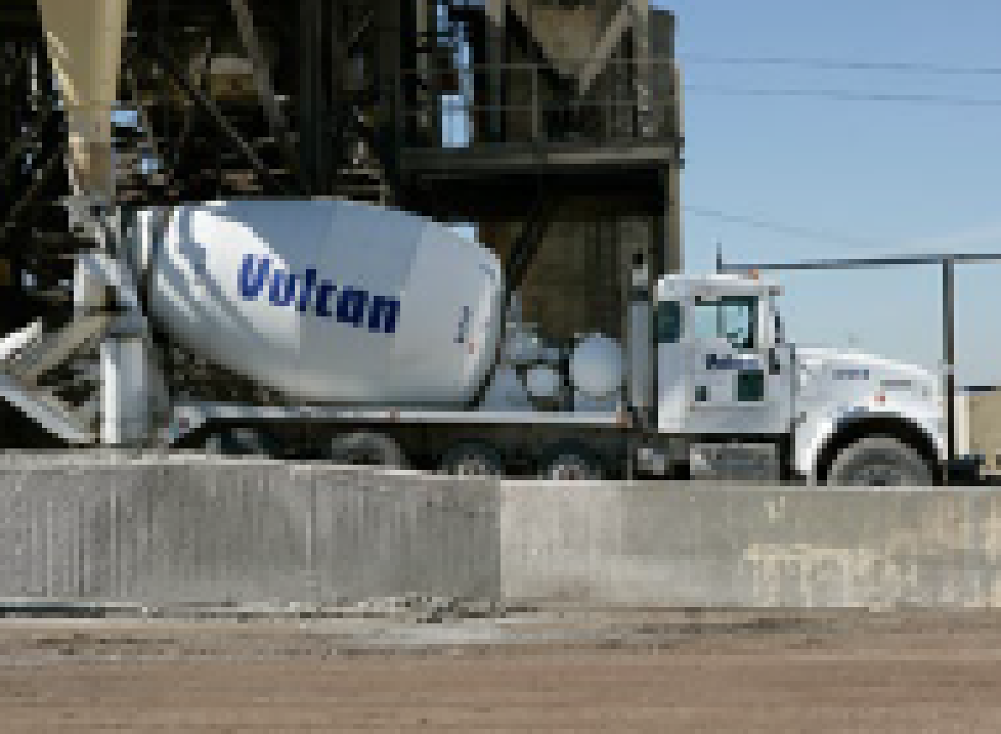

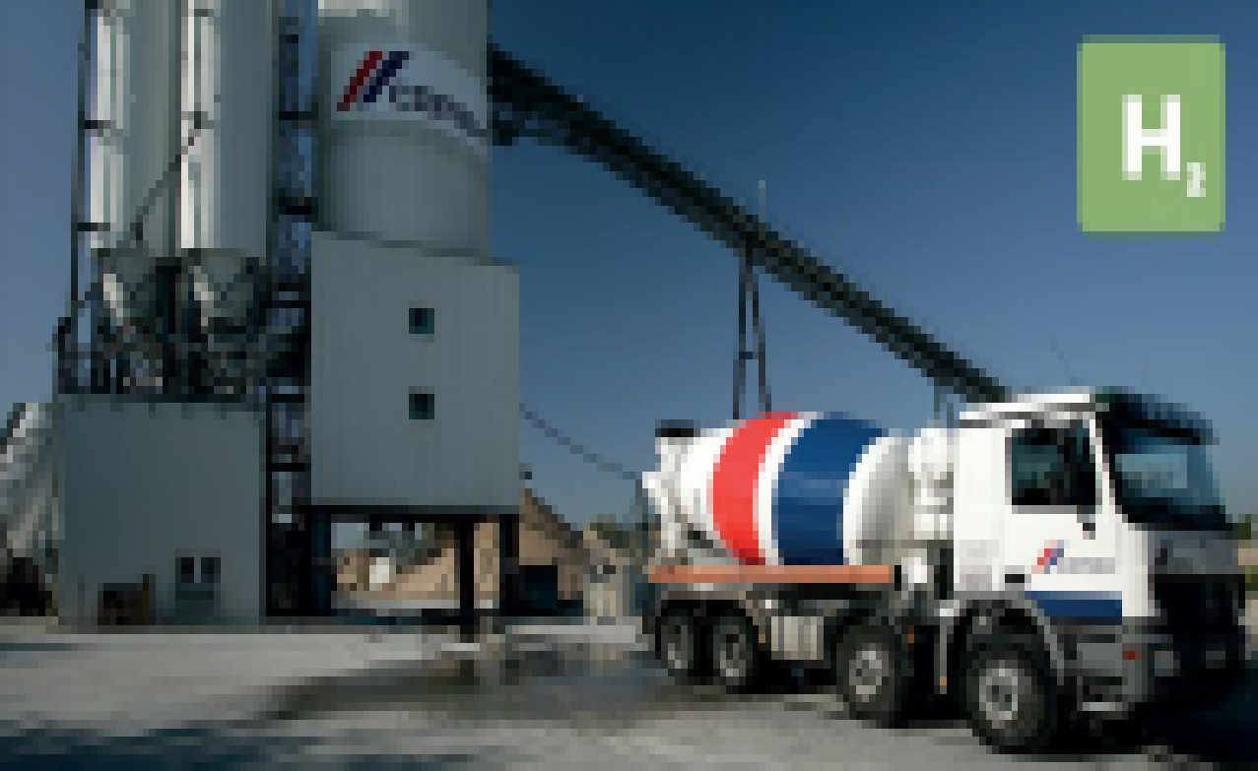
25. FIRMS FROM SECTION C INVOLVED WITH THIS PROJECT
a. | (1) FIRM NAME  S2 Engineering, Inc |  | (2) FIRM LOCATION (CITY AND STATE)  Rancho Cucamonga, CA |  | (3) ROLE  Prime Consultant - Plant Inspection Services

